**MS9001 Assignment 2**

**Name:** Timothy Ng Tik Ti

**Student ID:** P7362270

**Class:** AI03

**Research Question**

One very important aspect of national security is the deployment of forces to where it is most needed. By finding out which area requires more supervision and control, we then can allocate the right resources and manpower, reducing costs for the general public.

For this hypothetical study, we have chosen two cities within Tennessee as subjects, Knoxville and Lawrenceburg. These areas are known for their rate of violent crimes, and we would want to find out which of the two area is more dangerous to properly deploy resources.

**Obtaining Sample Data**

* We plan to obtain our data through government websites
* Sample: Crime rate for a period of number of years in Lawrenceburg. Crime rate for a period of number of years in Knoxville
* Population: Crime rate for the whole duration of living in Lawrenceburg. Crime rate for the whole duration of living in Knoxville
* Sample size: 15 years (2002 to 2017) for both data sets. Sampling method: Stratified sampling, one chosen from Lawrenceburg, and one chosen from Knoxville
* Types of data collected: discrete quantitative
* The data is collected through City-Data.com using python code, then processed in excel to be imported into Minitab for analysis. Below is a screenshot of the python code:  
  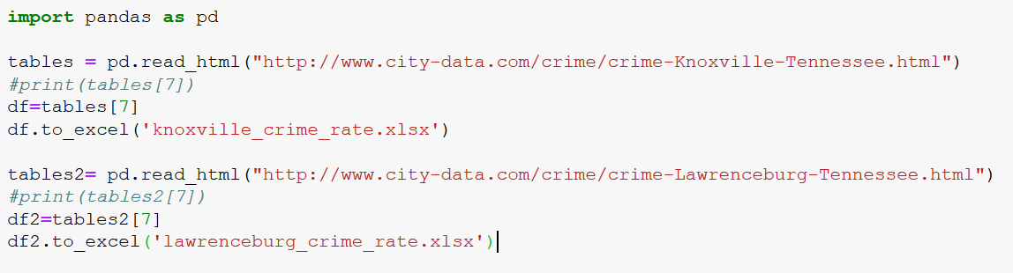

**Data Analysis**

*Assumptions*

One of the major assumptions is that utilizing the Crime Index by the City-Data algorithm, is sufficient to encompass all the violent crimes that occurred. Also, another assumption is that the security for the two cities stayed relatively constant through the years, without one city improving faster than the other.

After collecting data from website using python, the following data was input into Minitab to perform independent t-test

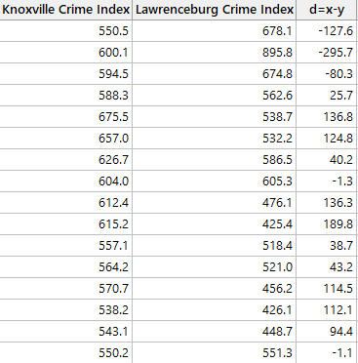

Our null hypothesis, H0, is thus   
d=x-y = 0  
And our alternate hypothesis, H1, is  
d=x-y =/= 0

where x is Knoxville Crime Index, and y is Lawrenceburg Crime Index.

For this study, we will take significance level to be 5%.

*Normality Test*

In order to perform the individual t-test, we would have to make sure that the difference from the sample follows a normal distribution. As such, we performed a normality test from Minitab.

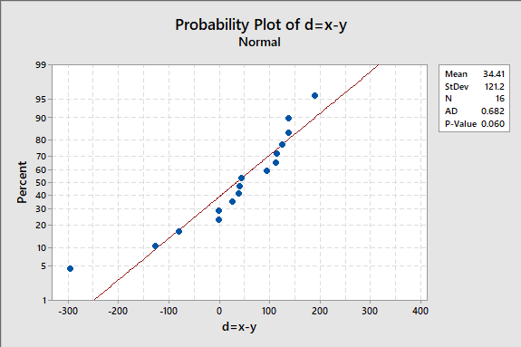

Since the points are close to the line and P-values is 0.06 (>5%), normality is not rejected based on 5% significance level.

*F-Test*

Now that we have established that the data are normal, we tested their equality of variances of the two samples obtained using F-test with significance level of 5%.

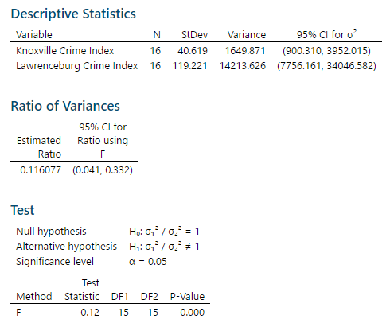

As the P-value of the test is 0.000, which is lower than the 5% significant level, and the ratio of variances excludes 1. We reject the null hypothesis of them having the same variance, and conclude that the two-samples have unequal variances.

*Independent T-Test with Unequal Variance*

Now that we have done the normality test and F-test, we proceeded to perform the t-test with unequal variances using the hypothesis mentioned above.

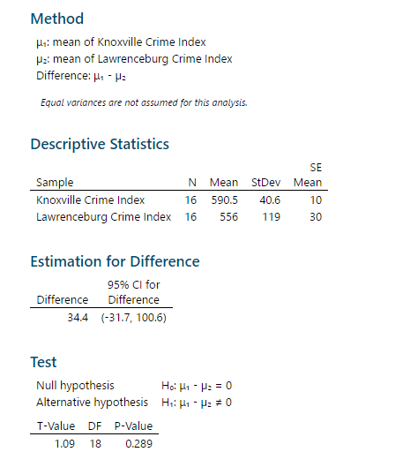

Since the P-value is 0.289, which is higher than the significant level of 5%, it is not rare to obtain a sample mean difference of 33.5 (590.5 – 556), if the difference of population mean of crime index is 0. As such, we are 95% confident that the population mean falls within the confidence range of -31.7 and 100.6, which includes the claimed difference of 0 crime index.

So we do not reject H0 at significance level of 5%.

**Conclusion**

Hence, there is no substantial evidence to show that Knoxville is more dangerous than Lawrenceburg, and vice versa.

However, it is good to note that there is still a chance of a type II error, where one city might be indeed more dangerous than the other, but we did not reject H0 for the samples that we have gotten.

**References**

1. <https://ucr.fbi.gov/crime-in-the-u.s/2016/crime-in-the-u.s.-2016/topic-pages/tables/table>2
2. <http://www.city-data.com/crime/crime-Lawrenceburg-Tennessee.html>
3. <http://www.city-data.com/crime/crime-Knoxville-Tennessee.html>